Maundy Thursday
April 9th 2020

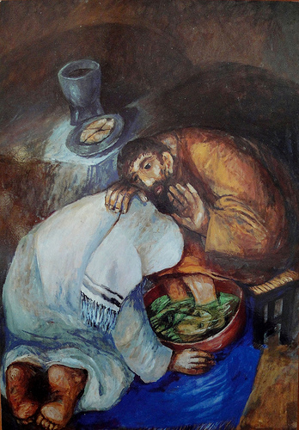

Introduction
Welcome to this time of worship as together we remember a night like no other; a night when heaven held its breath to see if Jesus would go through with it, would see his mission through to its shocking climax.
This is the night Jesus spoke with heavy heart about the pain of separation, yet carried on regardless knowing what was about to happen.
Prayer 1 (John Birch 2016)
Your love
flows like a stream
into the ocean of your Grace.
Your love
encircles this world,
displays your faithfulness.
Your love
is patient and kind,
brings wholeness and true peace.
Your love
is all we desire to heal our brokenness.
As all things pass and fade away
love remains eternally
Hymn
As the Deer
Reading
John ch 13 v 1-15
Reflection
Wash my Feet

Hymn
Come as you are
Prayer 2 (look at painting by Sieger Koder)
Creator God, we thank and praise you because you do not hold back from loving us;
you took the risk of conceiving humankind and, in your generosity, gave us all that we need,
asking of us only that we love you and one another.
Lord who kneels and washes our feet, teach us to love and serve.
Saviour God, we thank and praise you because you do not hold back from loving us;
you took the risk of sharing our human life and, in your generosity, gave that life for us,
asking of us only that we love you and one another.
Lord who kneels and washes our feet, teach us to love and serve
Spirit of God, we thank and praise you because you do not hold back from loving us;
you take the risk of going unnoticed as you live and move in our lives and world
asking of us only that we open ourselves to your power.
Lord who kneels and washes our feet, teach us to love and serve
Hymn
From Heaven you Came

Prayer
“And when they had sung a hymn, they went out to the Mount of Olives.”

Lord, help us to go out with you, to journey with you, to follow you,
allowing your love to heal and transform us and through us your world. Amen

Image
The Washing of the Feet by Sieger Koder
Prayer 2 taken from
Open with God
by Christine Odell © 2004 Inspire, Peterborough

