HolyTuesday- Jesus Goes to the Mount of Olives
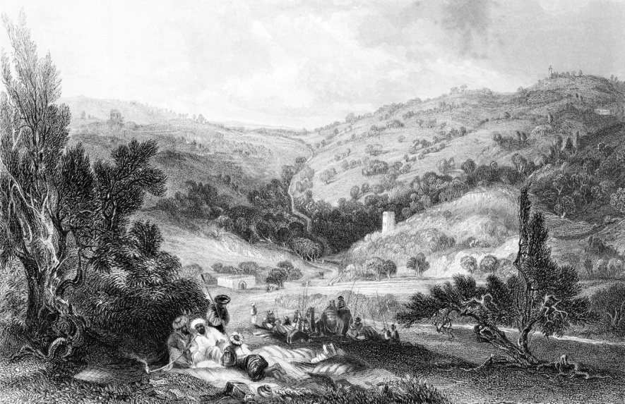
The Mount of Olives. Andrew_Howe / Getty Images

Hello, God’s beautiful pilgrims

As we continue with one another through this most tumultuous of times I repeat and echo a prayer of generations...
Lord Jesus Christ, Most Merciful Redeemer, Friend and Brother, help us this day and everyday to see Thee more clearly,
to follow Thee more nearly, to love Thee more dearly,
for Thy Name’s sake. Amen.
The tumultuous events of Tuesday and the Mount of Olivet Discourse/s are recorded in Matthew 21:23–24:51, Mark 11:20–13:37, Luke 20:1–21:36, and John 12:20–38.
I am picking a text from John and one from the Epistles that speaks to me of a pivotal word HUMILITY-Are we not humbled by the power of Covid 19 but also humbled by the self sacrifice of thousands of people in the Emergency services and across so many sectors of our society. Not least people of faith in our City and surrounding villages making, creating and delivering food. As Denise and I have walked we have been humbled by the power of nature to re-emerge and such ‘greening’ of life. This is a powerful theme of Holy week as we move to Holy Wednesdays, Thursdays. Fridays Saturdays and Easter Sundays
John ch12 vv36... “While you have light, trust to the light so that you may become people of light.”

Philippians ch 2 vv 8-11 “And being found in appearance as a man, He humbled Himself and became obedient to death – even death on a cross!

A Brief Thought

Jesus emptied himself. He poured himself out for us.
His attitude was not directed to himself. It wasn’t ME, MINE. It was you, ours.
Have you caught the news reports of people in the midst of traumas people “who become people of light”!? I have so many named in my gratitude journal have you seen those individuals doing fun things on youtube to keep physically and mentally alert?
How can we live together as the community of God? With everything going on and really embrace this ingredient of Humility deeply folded into the mix, I think it boils down to this.
In our culture we are trained from childhood that life is all about ME, MINE, and MY WAY. Even our religion is based on MY relationship with God, My eternal destiny, MY beliefs. If I’m good with God, then I can check that off my list and move on with my life.
Here’s where the metamelomai happens.
What if we changed the ME, MINE, and MY WAY to WE, OURS, and GOD’s Way.
We are all the body of Christ. How We need each other everyone
This is our community both in this congregation and in the great Lincolnshire County
This is God’s Kingdom and we are called to be God’s hands and feet in this world.
Living together means sometimes letting go of things. It means admitting when we’re wrong and doing something about it. And it means looking out for each other.
That is humility.

A Hymn StF148 Come let us with our Lord arise TUNE Sussex Carol

1 COME, let us with our Lord arise,
Our Lord, who made both earth and skies;
Who died to save the world he made,
And rose triumphant from the dead;
He rose, the Prince of life and peace,
And stamped the day for ever his.
2 This is the day the Lord hath made,
That all may see his love displayed,
May feel his resurrection's power,
And rise again to fall no more,
In perfect righteousness renewed,
And filled with all the life of God.
3 Then let us render him his own,
With solemn prayer approach the throne,
With meekness hear the gospel-word,
With thanks his dying love record;
Our joyful hearts and voices raise,
And fill his courts with songs of praise.
4 Honour and praise to Jesus pay
Throughout his consecrated day;
Be all in Jesu's praise employed,
Nor leave a single moment void;
With utmost care the time improve,
And only breathe his praise and love. (Charles Wesley)

Closing Prayer
God our strength,
we lift to you the deepest prayers of our hearts
that you will save us from the time of trial
and comfort us in tribulation.
Prayers of the People, You pray a moment
Reveal your glory to the nations,
that your cross may stand
as a sign of the power
that conquers human pride
and confounds the wisdom of this world. Amen.
Holy and immortal God,
from earliest times
you have named us
and called us into discipleship.
Teach us to follow the One
whose light scatters the darkness of our world,
that we may walk as children of the light. Amen.

